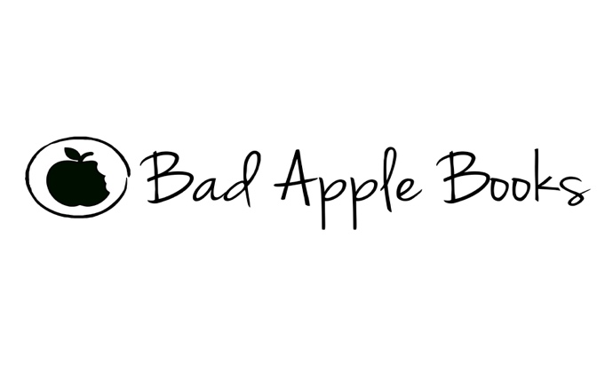
Contact: Jennifer G. Edelson
www.JenniferGEdelsonAuthor.com
www.BadAppleBooks.com
j.g.e.wagner@gmail.com
BadAppleBooksinfo@gmail.com
651-238-5856

FOR IMMEDIATE RELEASE

Local Author Debuts Critically Acclaimed Young Adult Novel, ‘Between Wild and Ruin’

Truth, Like Love, Isn’t Always Obvious
Especially in the Heart of New Mexico, Where Legends and Ghosts Aren’t Always Just Campfire Stories.

[Santa Fe, New Mexico, September 28, 2019] Bad Apple Books and debut young adult author, Jennifer G. Edelson are thrilled to announce an all-ages young adult book launch party at the Honeymoon Kombucha Brewery in Santa Fe, New Mexico, for the upcoming young adult paranormal romance, Between Wild and Ruin.

Between Wild and Ruin’s launch will take place inside the Honeymoon Brewery between 5:30-7:30 on September 28, 2019, where local author, Jennifer G. Edelson will be reading from Between Wild and Ruin, answering questions, and signing books. Bad Apple Books will also be hosting several New Mexico-centric raffles. Santa Fe newcomer, Honeymoon Brewery offers an eclectic array of homemade artisan alcoholic Kombucha, and Bad Apple Books will host non-alcoholic drinks and finger foods.

Set against a Northern New Mexico backdrop, Between Wild and Ruin is a young adult coming of age story that captures the wild and whimsical pulse of New Mexico through the eyes of teens Ruby Brooks, Angel Ruiz, and Ezra Lucero. The first book in the Wild and Ruin series, Between Wild and Ruin explores the time-tested credo ‘never judge a book by its cover’ through a paranormal lens, weaving Puebloan and Hispanic folklore and Southwest cultural narratives into tightly written, high-concept fiction ‘brimming with mystery, intrigue,’ and as Kirkus Reviews puts it, an “intriguing historical drama and an over-the top quadrangle romance.”

The novel’s author, Jennifer G. Edelson, a Santa Fe, NM local credits Northern New Mexico’s Glorieta Pass itself for the novel’s inspiration. “I was first drawn to writing a story set in the Pecos, NM area overall after spending numerous summers hiking the pass through the Sangre De Christo Mountains. I fell in in love with the geology, geography, and the people I met in the pass, especially around Glorieta and Pecos, and above all, the history of the land — even when I’m not there, it haunts me. Over time, I’ve grown firmly convinced that the story and the setting chose me, not the other way around. And I’m infinitely grateful!”

For interviews, or review copies of ‘Between Wild and Ruin’ contact Jennifer G. Edelson at j.g.e.wagner@gmail.com or 651-238-5856 or Bad Apple Books at BadAppleBookinfo@gmail.com

